ELET1215 APRIL/MAY 2017 SOLUTIONS Page 1

Question 1 Part (a)

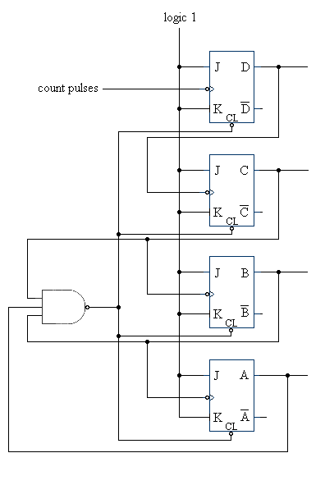

ELET1215 APRIL/MAY 2017 SOLUTIONS Page 2

Question 1 Part (b)

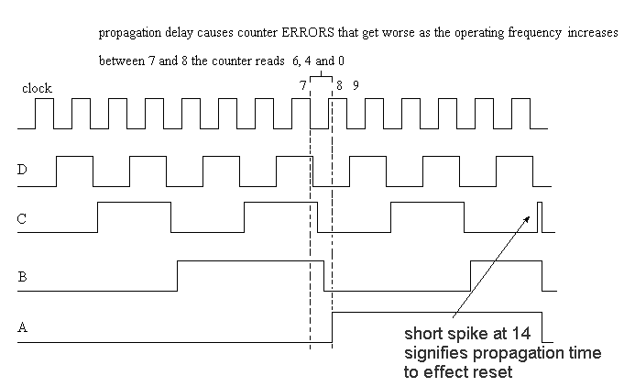

Question 1 Part (c)

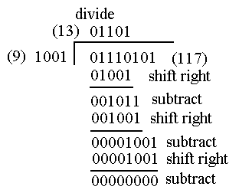

ELET1215 APRIL/MAY 2017 SOLUTIONS Page 3

Question 1 Part (d)

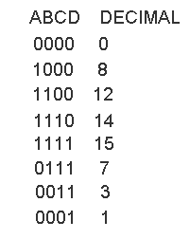

A correction circuit is needed for the switch-tail ring counter to ensure that there is never a zero between two of the ones because if this should happen (it could happen on power-up) without a correction circuit it would be unable to correct (i.e. the zero would circulate indefinitely).

ELET1215 APRIL/MAY 2017 SOLUTIONS Page 4

2. (a) 1st Row: input change : 01 to 11 input change: 01 to 00

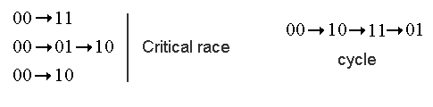

2nd Row: input change : 00 to 01 input change: 00 to 10

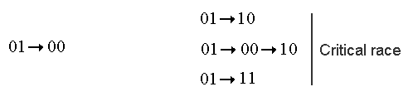

3rd Row: input change: 11 to 01 input change: 10 to 00

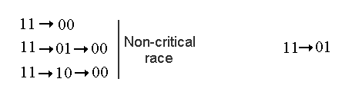

4th Row: input change: 11 to 01 input change: 10 to 00

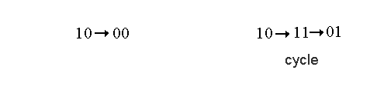

ELET1215 APRIL/MAY 2017 SOLUTIONS Page 5

2. (b)

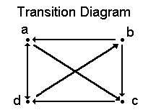

Expanded Flow Table

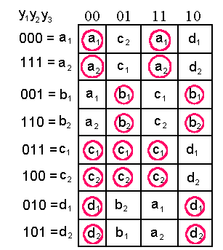

ELET1215 APRIL/MAY 2017 SOLUTIONS Page 6

2. (c)

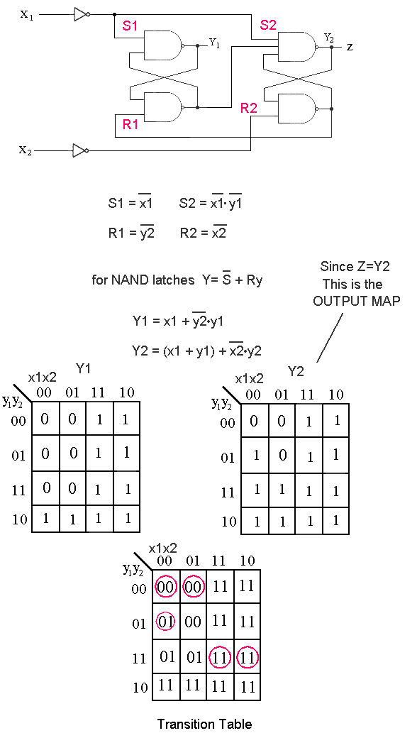

ELET1215 APRIL/MAY 2017 SOLUTIONS Page 7

3. (a) 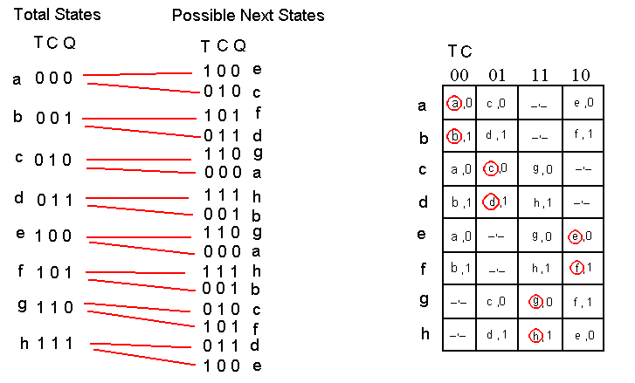

ELET1215 APRIL/MAY 2017 SOLUTIONS Page 8

3.(b)

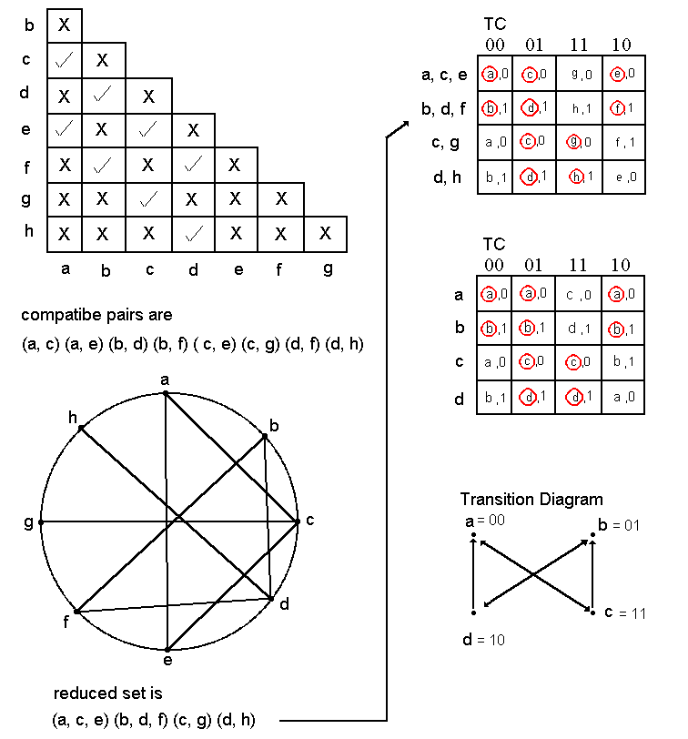

ELET1215 APRIL/MAY 2017 SOLUTIONS Page 9

3. (c) & (d)

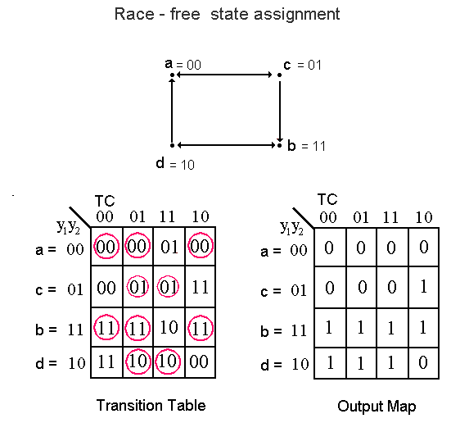

Output map can be impoved by realizing the 2 ‘don’t care’ situations



ELET1215 APRIL/MAY 2017 SOLUTIONS Page 10

3. (e)

S-R latch implementation



Complement functions for NAND latches



ELET1215 APRIL/MAY 2017 SOLUTIONS Page 11

Question 3 (e)

Logic Diagram



ELET1215 APRIL/MAY 2017 SOLUTIONS Page 12

4 (a)

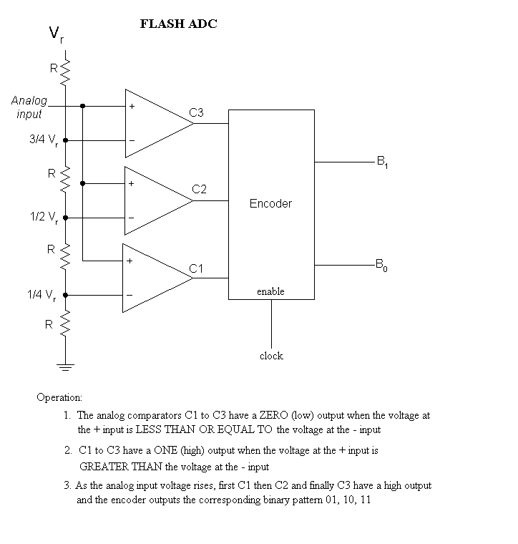

ELET1215 APRIL/MAY 2017 SOLUTIONS Page 13

4. (b)

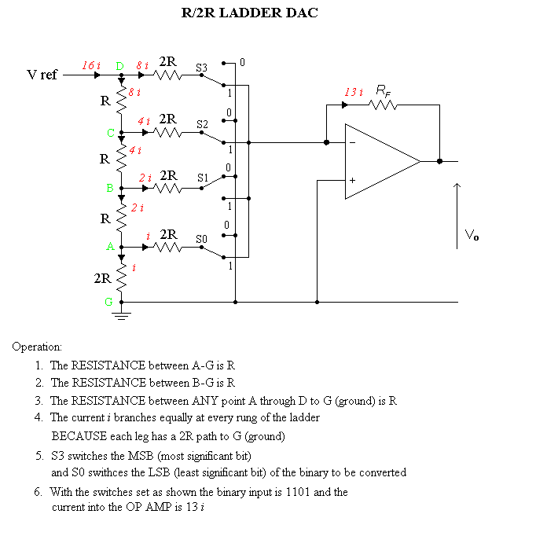

ELET1215 APRIL/MAY 2017 SOLUTIONS Page 14

4.(c)

The minimum change in the analog volatge that will cause a change in the least significant bit of the digitally converted number OR

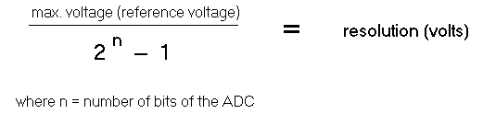

OR the voltage difference between two consecutive numbers of the binary conversion

(d)

The number of analog to digital conversions per unit time OR possibly

Increasing the sample rate results in more binary numbers that must be stored in the file but leads to better quality ausio or video.

(e)

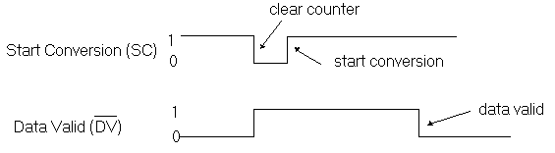

The time between the ‘start conversion’ and the ‘data valid’ is the time required for the ADC to convert the analog voltage to a digital number.